Quick Parent & Student Guide

School Website link: https://www.bridgepreppalmbeach

New Student Accounts
- A new student must visit your school website and create their account using the Create Account form.

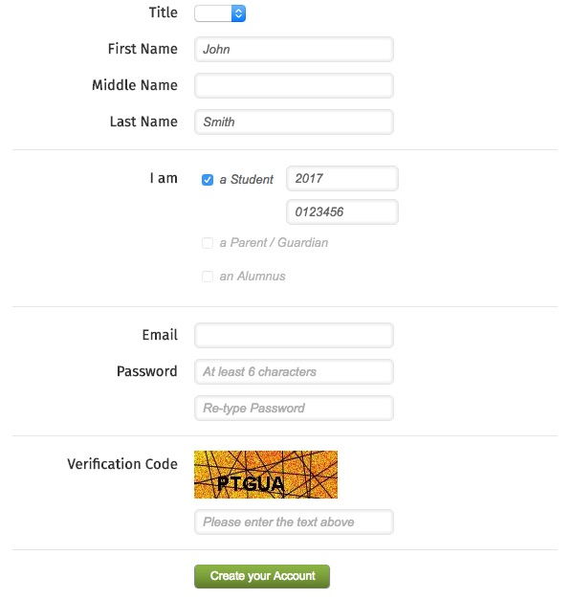

- After completing the new account form, a student will receive an email to verify their email address and activate their account. They must click the Activate Account button in the email they receive.
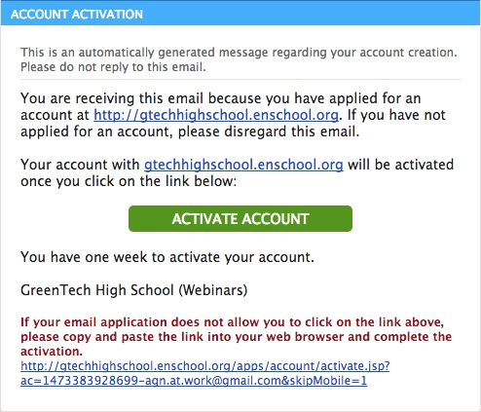
- After activating their account, they will receive an email with a verification code
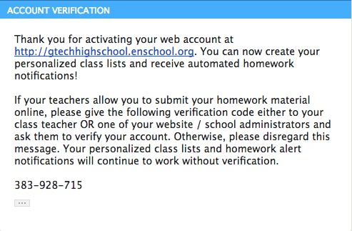
- The student must then physically give their verification code to one of their teachers.
- The teacher must then click on My Students and Parents from their admin area, and then click on the Verify Student Accounts button.
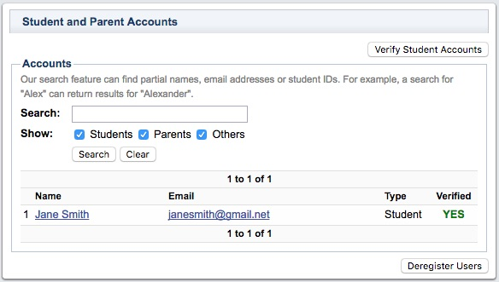
- The teacher will then enter the verification code provided by the student.

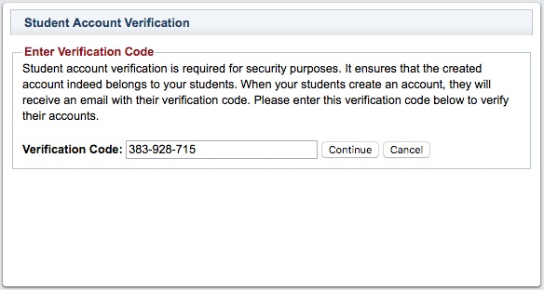

- After reviewing the student's information, click on the Approve button to complete the student verification process.
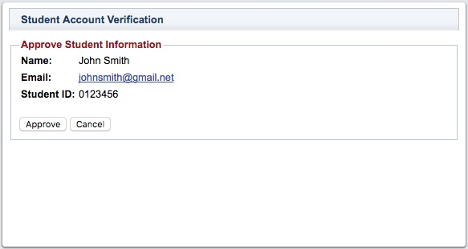

If your website doesn't have a Login / Create Account option, please contact Technical Support using the help desk and request for it to be added somewhere on your. show me

